About me page:

Picture:

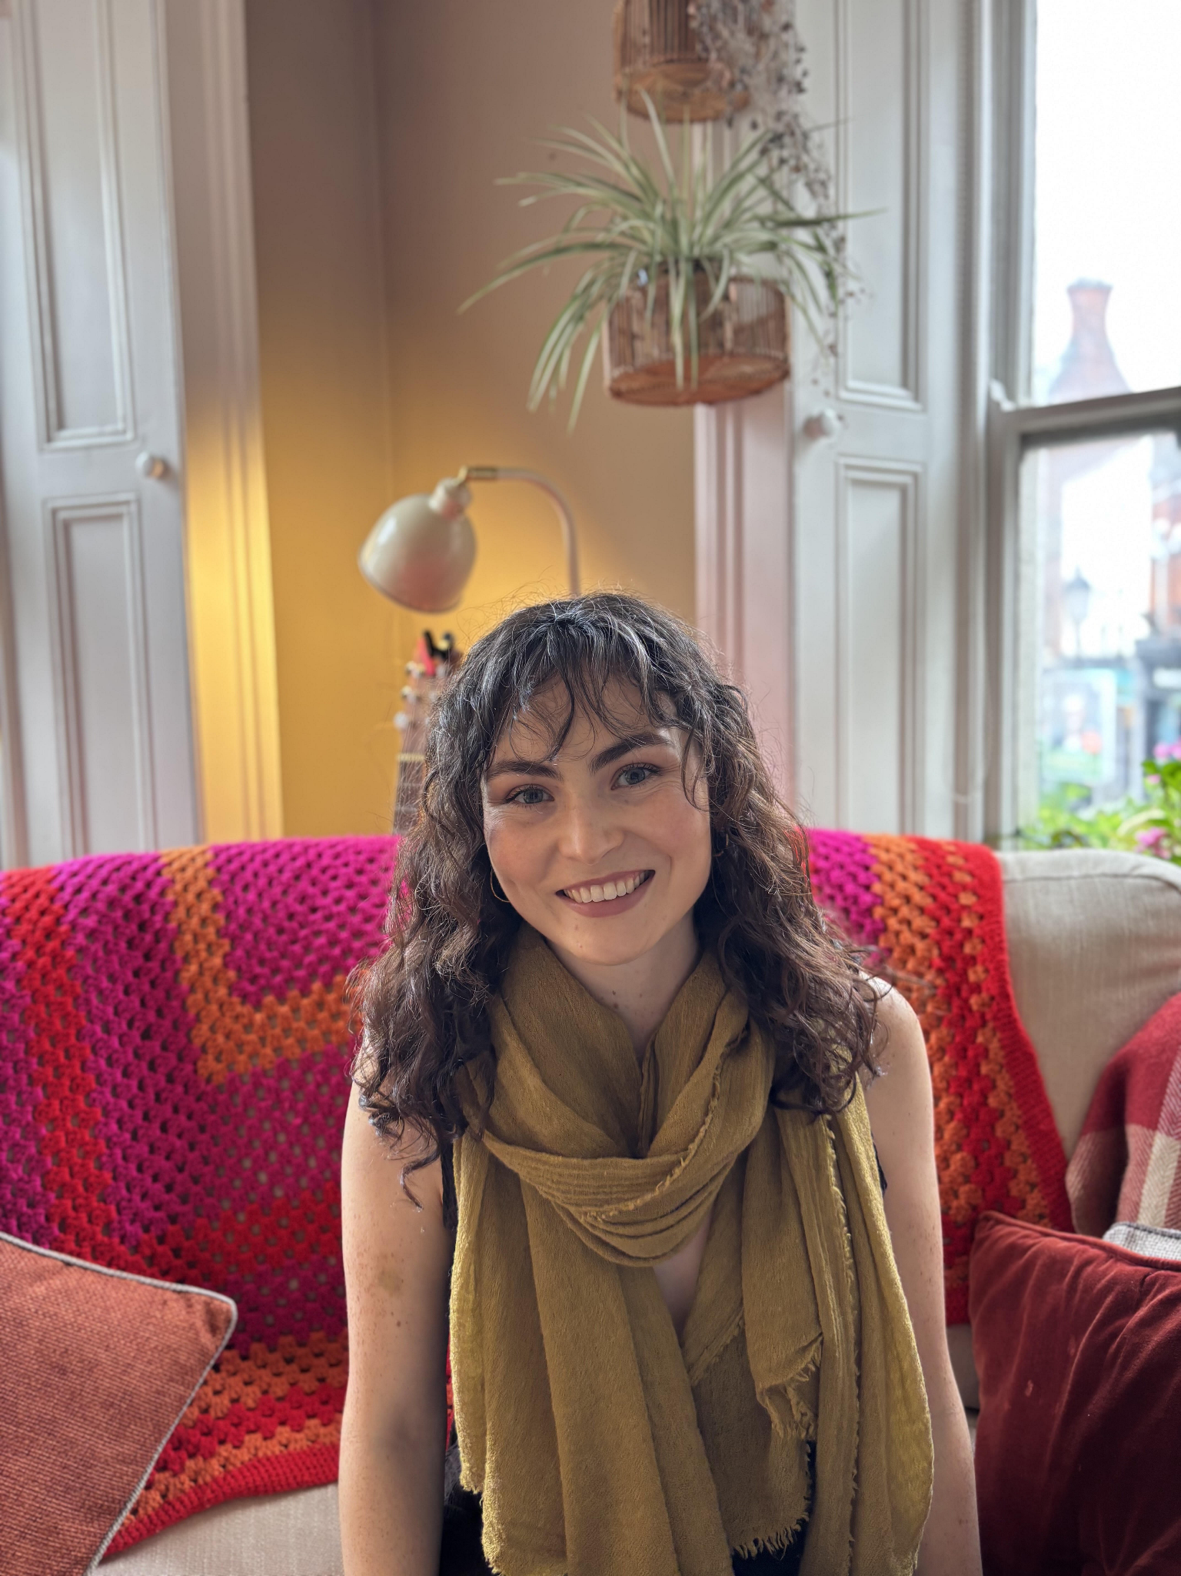

**About me:**

Empowering you to overcome blocks in both your body and mind, to step out of your comfort zone and achieve your goals. Creating lasting change through hypnotherapy and coaching.

My own experiences have fuelled my passion to help others build belief in themselves and learn how to express themselves authentically.

A pivotal point in my journey was learning about the power of my subconscious mind, and the importance of aligning body (emotions) with mind (thoughts). For the past three years I have been studying emotion, soma and solution focused hypnotherapy. I focus on building safety and stabilisation inside your body so that you have a secure base to thrive and achieve your desires.

**My qualifications:**

Diploma in Emotion, Soma & Solution focused Hypnotherapy with Hypnotherapy Business Academy

Professional Diploma in Coaching and Mentoring with Kingstown College

**My journey:**

My own interest in working with the mind began in my late teenage years when I first experienced a huge shift in my internal state. From as young as I can remember, I had been pretending to be different from who I actually was on the inside. I was acting like others around me because I thought it was right.

This led to me developing the habit of not being myself, falling into a persona, and not one that I particularly liked. When I moved away for the first time and found myself in a new environment around a completely new set of people - I felt no pressure to continue to be my 'false self'. I simply started to be me. The relief and joy this shift created was immense, and since then more and more I have found true happiness and contentment as I have gradually let go of the parts of myself that no longer align with the life I am creating. I have learned that authentic expression is ever evolving and that every day we wake up we have the potential to grow in new ways.

Services Page:

**Emotion and Soma focused hypnotherapy**

In this approach to hypnotherapy, I use a bottom up model, meaning we approach your challenges from the emotional roots. This is a slower-paced form of hypnotherapy that allows time for emotional release and recalibration.

In Emotion and Soma focused hypnotherapy we focus on three things:

1. Is there safety in your body? i.e. can you regulate your nervous system and bring yourself back to your resilient zone when times are tough.
2. Processing of difficult experiences / core wounds - once you have the skills and internal resources to regulate your nervous system we move on to processing difficult experiences that have left an imprint on your body and mind.
3. Once you have achieved the latter two steps we integrate the lessons from your past and begin to create the future you desire.

There is no one size fits all in Emotion focused work, everyone moves through the phases in their own time, the most important step on this journey is the first one. If this sounds like the right kind of therapy for you, book in for a free 30 minute consultation call to learn more.

**Coaching & Hypnotherapy package**

**Root to Rise**

*Learn how to embody the version of you who changes your goals into reality, aligning emotion with intention to create lasting change.*

Do you feel stuck in life? - You have an idea of what you want but it feels like a distant dream and you don't feel like you have what it takes to achieve it. You are stuck in negative feedback loops of feeling fearful and unworthy and all the thoughts that come with that.

***How would things change*** if you could finally embody the version of you who goes after your goals with intention, compassion and determination. How would it feel to let go of self-judgement and allow yourself to take small steps to a new way of being.

**Root to Rise is for you if:**

**You are:**

* Tired of playing small, worrying about the opinions of others
* Feeling stuck, fearful, demotivated
* Sick of comparing yourself to others, always feeling like you are behind

**& you are ready to:**

* Get clear on your vision, creating a roadmap to success
* Gain awareness of your subconscious blocks - in both your body and mind
* Step outside of your comfort zone - embodying the version of you who goes after your goals

**What is included?**

* Six one to one coaching and hypnotherapy sessions, to allow you to gain clarity, rewire beliefs and get in touch with the feeling of success
* Hypnotherapy recordings - to keep momentum up in between sessions and get your subconscious mind working for you
* Journal prompts between sessions to gain deeper insights and meaning

Get in touch if this sounds like the right program for you, and if you would like to discuss in more detail follow the link below for a free 30 minute discovery call.

Link to book a discovery call:

<https://calendar.app.google/nh6t6apqsXgQ5S2DA>

Blog Page:

**Beliefs - What are they and how to work with them.**

What if I were to tell you that every decision, every action you take, even the way you understand your experiences with other people are all controlled by your beliefs.

*Let's break it down:*

To define a belief; it is simply something you hold to be true without having evidence to back it up. We all have a myriad of beliefs about ourselves. Our subconscious mind is the storehouse for these beliefs and our conscious mind is running on the assumption that this belief system is true.

*What does this mean for you?*

Your mind does not care whether your belief system is positive or negative, either way it is trying to look for evidence that this belief system is correct.

For example:

* Your mind will perceive events in a certain way that validates it's belief, e.g. a person who believes that they are beautiful will interpret the lingering gazes of others in a different way than someone who believes they look weird and awkward
* Your behaviour will reflect your belief system e.g. if I believe I am stupid I am less likely to study for my tests or do my homework
* Your relationships with others will reflect your belief system. For example; the belief of not being worthy of love could manifest in a variety of ways - such as people pleasing or sabotaging a romantic relationship when it is going 'too well'

Our beliefs are primarily formed in childhood by the people closest to us, society, education and culture. As we have held the majority of our beliefs for as long as we can remember, it is important to learn how to identify them.

***How to identify your belief system?***

The key to identifying your beliefs is to observe the patterns that repeat in your life. Patterns can show up in different ways and consist of your behaviours, emotions, thoughts and actions.

Some ways to look out for these patterns are:

* Understanding your emotional triggers - do certain situations make you anxious? Or maybe a certain topic of conversation makes you feel agitated and annoyed. It may annoy you when people ask you about your career because you hold the belief that you are behind in life.
* What do you judge others harshly for? Oftentimes the things we judge others for are the standards we set for ourselves. If you judge someone for being too emotional it could be from a belief that emotions are a sign of weakness.
* What automatic assumptions do you jump to? For example, assuming someone doesn't want to be your friend when they don't reply to your messages quickly.

These are a few examples of how to observe your default way of being and how this leads you to the beliefs that are behind them. What situations arise in different ways that ultimately leave you with the same feelings and thoughts?

***How do you change your beliefs?***

The good news is, simply being aware of your beliefs is already a huge step to changing them.

This is a process that works for me when I want to challenge and change my belief system:

1. Identify your beliefs - as explained above.
2. Ask yourself - Is this true? And look for the evidence in your life to dispute this belief.
3. Ask yourself what you would prefer to be true. It is important to pick a statement that you can believe. E.g. If you are working on transforming the belief 'I am not ready' , a good replacement could be: 'every day I am ready for the next step'.
4. Rehearse your new belief - Ask yourself how would someone who holds this new belief behave and begin to embody that way of being in your everyday life. As you do this, the behaviours associated with your old belief will become evident. It is important that you take note of how they show up and correct them.
5. Have compassion - changing beliefs can take time and patience, so be kind to yourself when you catch yourself falling into old ways of being, and allow yourself time to grow.

Knowledge is a powerful catalyst to change . Challenge yourself to identify your beliefs both positive and negative and see how they have been playing out in your life. Some beliefs are harder to shift than others. If you would like support on your journey, book a free 30 minute discovery call to discuss how we can work together.

Contact Page:

Link to discovery call:<https://calendar.app.google/nh6t6apqsXgQ5S2DA>

Location: Dublin and Online

Phone: 0851289996

Email: info@joannecolfer.com

Link to instagram: <https://www.instagram.com/joannecolfer?igsh=MXMxZ3B4M3djbzlvZw%3D%3D&utm_source=qr>